**Time & Material Billing SOP & Exceptions**

Table of Contents

I. SAS Detailed To Be Invoiced Report (To Be Generated Before Bulk Invoicing Window) 1

II. Generate T&M Customer Invoice (In Case Revenue Is Computed but Not Invoiced) 3

A. Invoice Generation for T&M 3

B. Review Draft Invoice Lines 6

C. Submit Invoice for Approval 6

D. Release Approved Invoice 7

III. Generate T&M Prepaid Customer Invoice 9

A. Prepayment Event Creation for T&M 9

B. Review Draft Invoice Lines 14

C. Submit Invoice for Approval 14

D. Release Approved Invoice 14

IV. Draw Down Prepaid T&M Invoicing 16

A. Prepayment Applied Event Creation for T&M 16

B. Review Draft Invoice Lines 21

C. Submit Invoice for Approval 22

D. Release Approved Invoice 22

V. Exceptions 24

A. Itali (530) 24

B. Philippines (430) and Singapore (435) 26

C. Malaysia (436) and Thailand (437) 27

D. Poland (740) 28

E. Denmark (520) 31

Table of Versions

|  |  |  |
| --- | --- | --- |
| Sr. No. | Date | Version |
| 1 | 23/01/2025 | SAS-TM-SOP-V1 |
| 2 | 07/02/2025 | SAS-TM-SOP-V2 |
| 3 | 24/03/2024 | SAS-TM-SOP-V3 |
| 4 | 04/04/2025 | SAS-TM-SOP-V4 |

# SAS Detailed To Be Invoiced Report (To Be Generated Before Bulk Invoicing Window)

1. Project Owner goes toTools -> Reports and Analytics.

1. Click on Browse Catalog.

1. Path to the report: Shared>Custom>SAS Custom>Reports>PA>Reports

1. Enter details:
2. a. Business Unit = BU_CC_XXX
3. b. Project Owner = your name
4. c. Send Email = Y
5. d. Apply

1. An automatic email will be sent to all the Project Managers directly from Fusion
2. Based on the approval replies from Project Managers, Project Owners will submit the draft invoices from approved times cards and release them.
3. For line items which are not showing Bill Amount, Labor Rate, Labor Hours, Prepayment flag, Revenue distribution the Project Owner needs to connect with the respective Project Manager and cross check the contract details as below:

For detailed reporting SOP refer [link](https://sasoffice365.sharepoint.com/:w:/r/sites/EMEAGASCPTC/Shared%20Documents/General/Reports/Job%20Aids/Fusion%20Reporting%20SOP%20V1.docx?d=we7a787abe826476689e00b15ef25c9e4&csf=1&web=1&e=iJAYFp)

# Generate T&M Customer Invoice (In Case Revenue Is Computed but Not Invoiced)

## Invoice Generation for T&M

1. Project Owner goes toContract Management -> Invoices.

1. Click on Tasks on the right-hand side - list will be displayed with process options.
2. Click on Generate Invoices – process entry will be displayed.

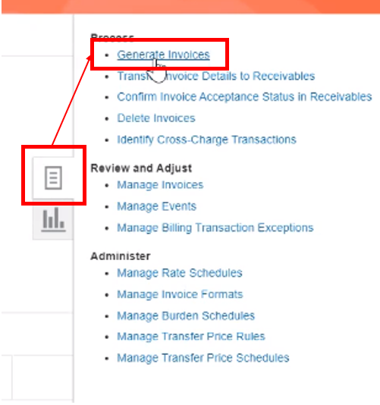

1. Input parameters and click Submit – parameters include:
2. Business Unit = XXX_CC_CUR
3. Billing Type = External
4. Bill Through Date = adjust as needed; will capture only expenditures through this date
5. Invoice Date = adjust as needed; date will print on invoice
6. Contract Number =
7. Generate Ineligible Data = Detail
8. Debug Mode = Yes
9. Recommended process is to submit ‘generate draft invoice process for a single contract.’

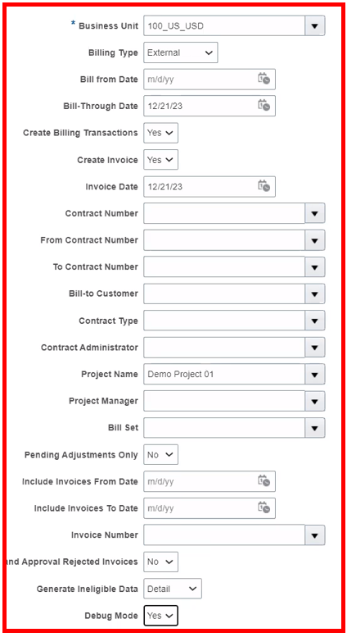

1. Now Expand 'Process Monitor' dropdown & click the refresh icon.
2. Click Refresh until the status of the report equals 'Succeeded'.

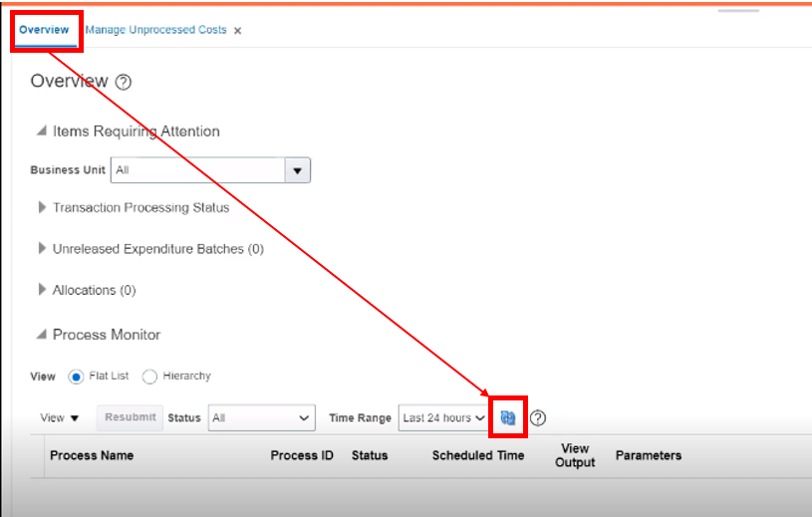

1. Review invoice processing status:
2. Click on the View Output icon next to the 'Generate Report' option of the process.
3. Click the 'Republish' icon.
4. Click the yellow 'View Report' icon.
5. Select PDF.

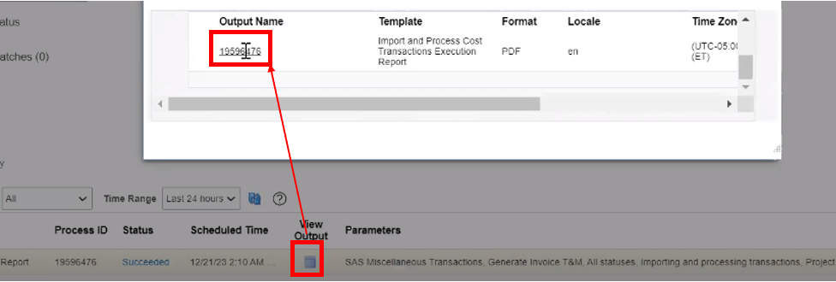

1. Navigate to Contract Management -> Invoices.

1. Select 'Manage Invoices' from the Task panel.

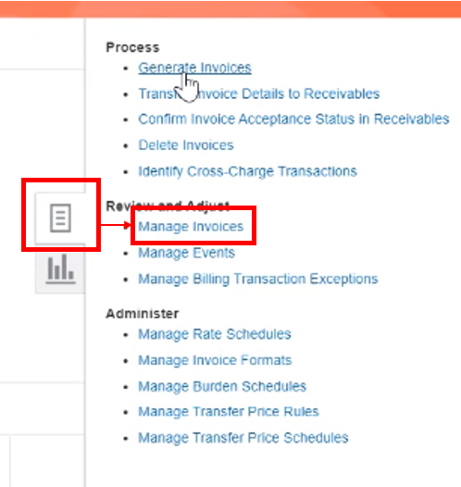

1. Select Business Unit from the drop-down list and key in 'Contract Number', then click on Search.

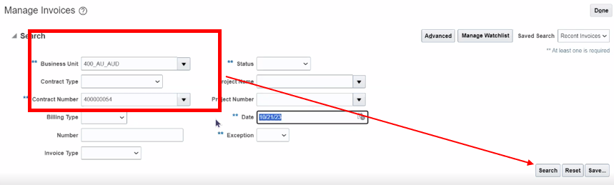

1. Invoice details for contract appears.
2. Now the Billing Specialist will review the draft invoice lines.

## Review Draft Invoice Lines

1. Click on appropriate Invoice Number link.
2. Invoice details screen will be displayed.

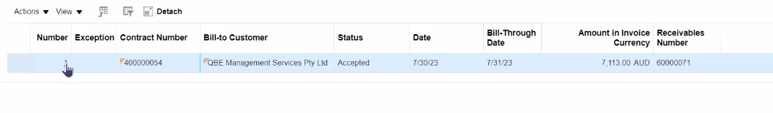

1. Validate invoice description, billing titles, billing rates, work types.
2. Now Billing Specialist will submit the invoice for approval.

## Submit Invoice for Approval

1. Go to Actions > Submit.
2. Project invoice will be submitted for approval.
3. The Project Manager will receive notification to approve the invoice.

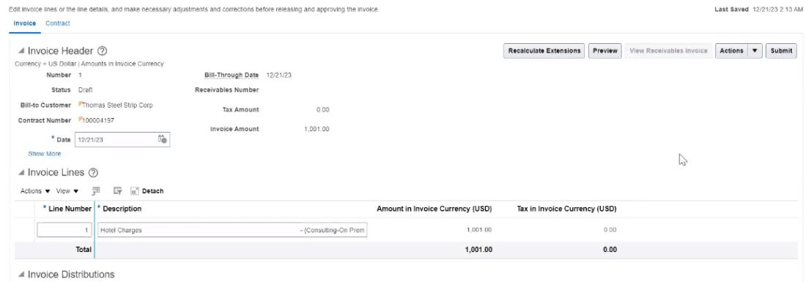

1. Along with the request for approval, a communication with an attachment including the invoice details is triggered and sent to the Project Manager. The attachment is for internal use only. If customer approval is needed on an invoice, ensure the formal invoice is sent.

## Release Approved Invoice

1. Contract Management -> Invoices.

1. Click on Task Panel -> Review and Adjust -> Manage Invoices.
2. Invoices work area will be displayed.



1. Enter Business Unit, Contract Number and status as 'Approved', click on Search.
2. Invoice search screen will be displayed.



1. Highlight the appropriate invoice.
2. Invoices based on search criteria will be displayed.

1. Go to Actions -> Release.
2. Project invoice status will change to 'Released' and invoice is ready to be imported to AR.

# Generate T&M Prepaid Customer Invoice

## Prepayment Event Creation for T&M

1. Click on Navigator > Contract Management > Invoices.

1. Click on Tasks Panel and select Manage Events.

1. Click on '+' icon under Search Results section to create an Event.

1. Enter required fields:  
    Business Unit  
    Contract Number  
    Contract Line  
    Event Type = Prepayment - Labor  
    Event Description = Prepayment services (As per directed by your region SME)  
    Amount in Bill Transaction Currency = Invoice Prepaid Amount  
    Completion Date  
    Project Name  
    Transaction Task Name (top task associated with contract line)
2. Review Event Revenue and Invoice eligibility, confirm correct.
3. Select 'Work Type - Tax Code' under 'Additional Information' section.
4. Click on 'Save and Close'.

1. Project Owner goes to Contract Management -> Invoices.

1. Click on Tasks on the right-hand side - list will be displayed with process options.
2. Click on Generate Invoices – process entry will be displayed.

1. Input parameters and click Submit – parameters include:
2. Business Unit = XXX_CC_CUR
3. Billing Type = External
4. Bill Through Date = adjust as needed; will capture only expenditures through this date
5. Invoice Date = adjust as needed; date will print on invoice
6. Contract Number =
7. Generate Ineligible Data = Detail
8. Debug Mode = Yes
9. Recommended process is to submit ‘generate draft invoice process for a single contract.’

1. Now Expand 'Process Monitor' dropdown & click the refresh icon.
2. Click Refresh until the status of the report equals 'Succeeded'.

1. Review invoice processing status:
2. Click on the View Output icon next to the 'Generate Report' option of the process.
3. Click the 'Republish' icon.
4. Click the yellow 'View Report' icon.
5. Select PDF.

1. Navigate to Contract Management -> Invoices.

1. Select 'Manage Invoices' from the Task panel.

1. Select Business Unit from the drop-down list and key in 'Contract Number', then click on Search.

1. Invoice details for contract appears.
2. Now the Billing Specialist will review the draft invoice lines.

## Review Draft Invoice Lines

1. Click on appropriate Invoice Number link.
2. Invoice details screen will be displayed.

1. Validate invoice description, billing titles, billing rates, work types.
2. Now Billing Specialist will submit the invoice for approval.

## Submit Invoice for Approval

1. Go to Actions > Submit.
2. Project invoice will be submitted for approval.
3. The Project Manager will receive notification to approve the invoice.

1. Along with the request for approval, a communication with an attachment including the invoice details is triggered and sent to the Project Manager. The attachment is for internal use only. If customer approval is needed on an invoice, ensure the formal invoice is sent.

## Release Approved Invoice

1. Contract Management -> Invoices.

1. Click on Task Panel -> Review and Adjust -> Manage Invoices.
2. Invoices work area will be displayed.

1. Enter Business Unit, Contract Number and status as 'Approved', click on Search.
2. Invoice search screen will be displayed.

1. Highlight the appropriate invoice.
2. Invoices based on search criteria will be displayed. Click on appropriate Invoice line item

1. Go to Actions -> Release.
2. Project invoice status will change to 'Released' and invoice is ready to be imported to AR.

# Draw Down Prepaid T&M Invoicing

## Prepayment Applied Event Creation for T&M

1. Click on Navigator > Contract Management > Invoices.

1. Click on Tasks Panel and select Manage Events.

1. Click on '+' icon under Search Results section to create an Event.

1. Enter required fields:  
    Business Unit  
    Contract Number  
    Contract Line  
    Event Type = Prepayment Applied - Labor  
    Event Description = Prepayment Applied Services (As per directed by your region SME)  
    Amount in Bill Transaction Currency = Invoice Prepaid Amount (Negative)  
    Completion Date  
    Project Name  
    Transaction Task Name (top task associated with contract line)
2. Review Event Revenue and Invoice eligibility, confirm correct.
3. Select 'Work Type - Tax Code' under 'Additional Information' section.
4. Click on 'Save and Close'.

1. Project Owner goes to Contract Management -> Invoices.

1. Click on Tasks on the right-hand side - list will be displayed with process options.
2. Click on Generate Invoices – process entry will be displayed.

1. Input parameters and click Submit – parameters include:
2. Business Unit = XXX_CC_CUR
3. Billing Type = External
4. Bill Through Date = adjust as needed; will capture only expenditures through this date
5. Invoice Date = adjust as needed; date will print on invoice
6. Contract Number =
7. Generate Ineligible Data = Detail
8. Debug Mode = Yes
9. Recommended process is to submit ‘generate draft invoice process for a single contract.’

1. Now Expand 'Process Monitor' dropdown & click the refresh icon.
2. Click Refresh until the status of the report equals 'Succeeded'.

1. Review invoice processing status:
2. Click on the View Output icon next to the 'Generate Report' option of the process.
3. Click the 'Republish' icon.
4. Click the yellow 'View Report' icon.
5. Select PDF.

1. Navigate to Contract Management -> Invoices.

1. Select 'Manage Invoices' from the Task panel.

1. Select Business Unit from the drop-down list and key in 'Contract Number', then click on Search.

1. Invoice details for contract appears.
2. Now the Billing Specialist will review the draft invoice lines.

## Review Draft Invoice Lines

1. Click on appropriate Invoice Number link.
2. Invoice details screen will be displayed.

1. Validate invoice description, billing titles, zero amount, work types.
2. Add billing instructions so that this invoice of zero amount does not directly go to customers
3. Now Billing Specialist will submit the invoice for approval.

## Submit Invoice for Approval

1. Go to Actions > Submit.
2. Project invoice will be submitted for approval.

1. The Project Owner will approve the invoice.

## Release Approved Invoice

1. Contract Management -> Invoices.

1. Click on Task Panel -> Review and Adjust -> Manage Invoices.
2. Invoices work area will be displayed.

1. Enter Business Unit, Contract Number and status as 'Approved', click on Search.
2. Invoice search screen will be displayed.

1. Highlight the appropriate invoice.
2. Invoices based on search criteria will be displayed.

1. Go to Actions -> Release.
2. Project invoice status will change to 'Released' and invoice is ready to be imported to AR.

# Exceptions

## Itali (530)

1. How to identify the Tax type for Italy Customers

While creating the budget for the project, there is an exception we follow for Italy region regarding Tax Type.

First, we go under **Manage Financial Project Settings**, you will see the screen as below for project under Fusion.

Here, there are two fields that we need to enter. One is Context Prompt, and another is Tax Type.

We must select the Context Prompt as **INVOICE ITALY** and there are three types of taxes which are as follows:

* I - For given type we use tax code “**I**”
* SP - For given type we use tax code “**S**”
* I*SP - For given type we use tax code “**S**”

1. Examples as Follows for all Tax types of Customers and you will find the

For example – For customer “Accenture Financial Advanced Solutions and Technology & SRL” the tax type is I, So will be considering “I” as Tax type.



For customer “Alma Mater Studiorum – Universita Di Bologna” the tax type is SP, So will be considering “S” as Tax type.



For customer “Age. Na. S – Agenzia Nazionale per I Servizi” the tax type is I*SP, So will be considering “S” as Tax type.



## Philippines (430) and Singapore (435)

1. In Philippines and Singapore, we add Billing instructions as “**Do not send to Client, PM to Check**” and attachments as well.

1. In Singapore we upload invoices on customer portal. There are two customers i.e., OCBC & Ariba. The invoices generated in Fusion will be copied to the Project Manager and DMO.

1. In Philippines, due to government regulations, the invoice needs to be manually created by the SAS local finance team and send it to the customers. Invoices from Fusion will be generated as per process and mark the local finance team in copy. When the manual invoices are created by the team, they will copy DMO and TCS team while sending to the customer.
2. Local finance contact:
3. Maria Rosalie Alicante - Rosalie.alicante@sas.com
4. Sharon Flores - Sharon.Flores@sas.com

## Malaysia (436) and Thailand (437)

1. In Malaysia and Thailand, we do not add billing instructions, but we add attachments.

## Poland (740)

1. **ING invoices** - Customer Name: ING Bank Śląski S.A.

There is a specific requirement by this customer that they want a different name on the Bill to Site and a different name on the Ship to Site.

There is something called the NIP number or the tax number, which we cannot see on the preview invoices, but it's something that will be visible on the final invoice after the PDF is generated **because there are two different entities i.e., one is parent company (ING Bank Śląski S.A.), and another one is subsidiary company (Grupa VAT ING, Grupa VAT Pekao).** In such case the address will be the same, but the name of the customer will be different, hence there is requirement that a different name should be on the bill to site and on the ship to site and therefore two different NIP numbers should appear on.

The final invoice, to achieve this, we need to create the contract in a different way. so first we need to amend the contract because it was created incorrectly.

For the contract amendment we can use the below mentioned contract number as ref.: 740000045

1. Steps to Amend the Contract.
2. Go to the Action Tab then select the option Amend

1. For example, contract number 740000439 will go and amend
2. Go to Parties tab change the Customer Name from ING Bank to Grupa VAT ING

1. Once we change the Customer in Parties tab The same customer Information need to be update in Bill to site as well.
2. Note: Only Bill-to site need to change Ship-to site remains the same.

1. Go to Lines tab > Check the Ship to site should be aligned with the same information which we put in Parties tab.

1. Go to Billing tab > Bill Plans > Click on Labor FP Bill Plan
2. Customer information should be the same as we have filled in Parties Tab.

1. Note: For all ING projects, whether it's time and material or fixed price, we need to record the PO Number (Purchase Order Number) in contract.
2. Billing Tab

1. Lines Tab > Billing > PO Number

1. Once we update amended the contract, we need to put amendment effective date (Project Start date) and submit the contract for Approval.
2. **Split Invoice** -In the Polish region, the projects are splits into percentages and several contracts associated to split projects. For instance, 65% of the contract value should be invoiced to party “A” and the remaining 35% to party “B”.
3. **For Example:** The projects will have to be created separately by PM. If the contract value is 100,000 PLN, and the split is 65 to 35 percent, both projects will be used to invoice the 65% and remaining 35% because there are two customers (the split can be varied for instance, 50-50% or 95-05%)The DPM attached will be full value of the contract also split information must be mentioned in the project under notes.

1. Both Revenue and raw cost will be split between projects as 65% and 35%. The invoice will be events based (Milestone) and Revenue method (Amount Based) only because it is not possible for the project managers to modify the hours according to the splits. So, the contract record must be created using a time and material template, though Project Task Rate Overrides and Cost Rates Overrides will be skipped.

## Denmark (520)

1. A **Skat** (meaning Danish tax duties) invoice is a customized type of invoice, we receive a request in an Excel sheet from the PM. The sheet includes the starting and ending dates for the invoice period, along with descriptions of the invoices. There are some variations in the descriptions, such as the use of "W-94989" at the beginning. Occasionally, a single project is associated with multiple resources, with invoices created for individual resources under the same project. For instance, for January 2024, we are working on the first week, which runs from January 1st to January 28th, covering weeks 44 to 47 in the current period (period 11).

1. The Excel sheet received from PM is a working needed before invoicing process as it contains details such as the Project Number, Contract Number, Name of the Resource, Description in Invoice, Bill through date, Bill from date, and Status.

1. While working for January 2024 (period 11), from 1st week and to 4th Week. So, the date falls from 1st of January to 28th of January i.e., week 44 to 47.

1. Select Contract Management > Invoices

1. Click on Taskbar > Generate Invoices.

1. Business Unit: For invoice to be created
2. Bill From date: 10/28/2024
3. Bill through date: 11/24/2024
4. Contract Number: For which we are invoicing.
5. Generate Ineligible Data: Detail.
6. Debug Mode: Yes
7. Click on Submit

1. Check whether the submitted invoice is reflecting with same proposed hours: It will show in the description of invoice. Once checked, need to paste the description from excel sheet provided by PM.

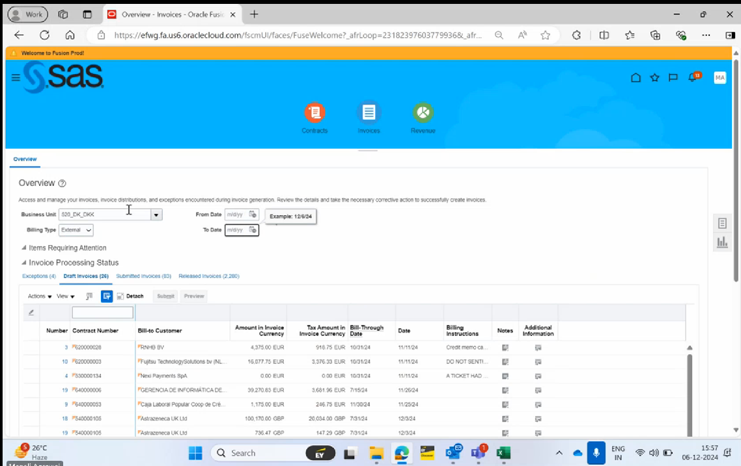

1. If proposed hours have been invoiced then submit for approval if not then check availability of funds in contract under little billing tab and if funds are not available then to check budget if there are any fund enhancement request updated, if not reach out to the PM.

***Process End***

Escalation Matrix

|  |  |  |  |
| --- | --- | --- | --- |
| Name | Level | Email Address | Landline/Phone Number |
| Bhaswar Banerjee | Level 1 | bhaswar.banerjee@sas.com | N/A |
| Agnieszka Bartuzi | Level 2 | agnieszka.bartuzi@sas.com | +48 22 560 45 83 |
| Beata Kienorow-Gulan | Level 2 | beata.kienorow-gulan@sas.com | +48 22 560 45 69 |